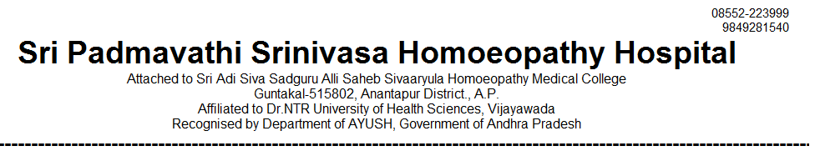
OUT PATIENT STATEMENT FOR THE YEAR JAN-2020 TO DEC - 2020

SNO | MONTH | GENERAL MEDICINE | GYNAECOLOGY /OBSTERICIAN | PAEDIATRICS | SURGERY | TOTAL
1 | 2020 - JAN | 2997 | 1447 | 1068 | 568 | 6080
2 | 2020 - FEB | 2860 | 1389 | 1049 | 563 | 5861
3 | 2020 – MAR | 2440 | 1231 | 930 | 457 | 5058
4 | 2020 - APR | COVID - 19
5 | 2020 - MAY
6 | 2020 - JUN
7 | 2020 - JUL
8 | 2020 - AUG
9 | 2020 - SEP
10 | 2020 - OCT
11 | 2020 - NOV | 1099 | 545 | 491 | 177 | 2312
12 | 2020 - DEC | 2055 | 1405 | 1063 | 349 | 4872
TOTAL | 12 MONTHS | 11451 | 6017 | 4601 | 2114 | 24183

