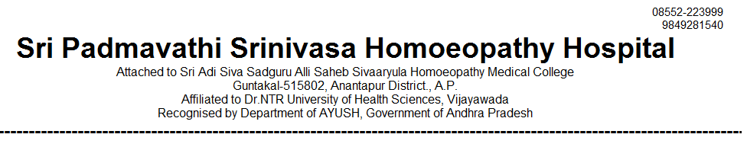
OUT PATIENT STATEMENT FOR THE YEAR JAN-2021 TO APR - 2021

SNO | MONTH | GENERAL MEDICINE | GYNAECOLOGY /OBSTERICIAN | PAEDIATRICS | SURGERY | TOTAL
1 | 2021 - JAN | 1826 | 1299 | 894 | 265 | 4284
2 | 2021 - FEB | 2836 | 1506 | 1103 | 561 | 6006
3 | 2021 – MAR | 3166 | 1615 | 1216 | 578 | 6575
4 | 2021 – APR | 2791 | 1428 | 1064 | 494 | 5777
