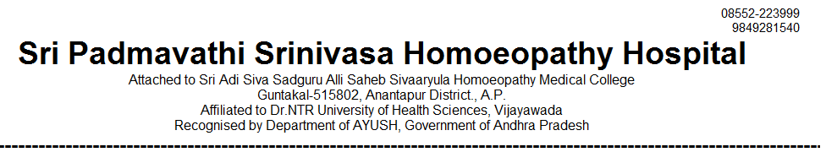
IN PATIENT STATEMENT FOR THE YEAR JAN-2019 TO DEC- 2019

SNO | MONTH | GENERAL MEDICINE | GYNAECOLOGY /OBSTERICIAN | SURGERY | PAEDIATRICS | TOTAL
1 | JAN | 37 | 7 | 5 | 4 | 53
2 | FEB | 36 | 5 | 4 | 2 | 47
3 | MAR | 28 | 8 | 5 | 6 | 47
4 | APRIL | 39 | 5 | 4 | 3 | 51
5 | MAY | 41 | 6 | 4 | 6 | 57
6 | JUN | 39 | 6 | 5 | 6 | 56
7 | JUL | 38 | 7 | 3 | 10 | 58
8 | AUG | 48 | 6 | 4 | 5 | 63
9 | SEP | 37 | 5 | 5 | 10 | 57
10 | OCT | 38 | 8 | 4 | 3 | 53
11 | NOV | 40 | 7 | 6 | 3 | 56
12 | DEC | 38 | 12 | 7 | 6 | 63
TOTAL | 12 MONTHS | 459 | 82 | 56 | 64 | 661

PRINCIPAL

